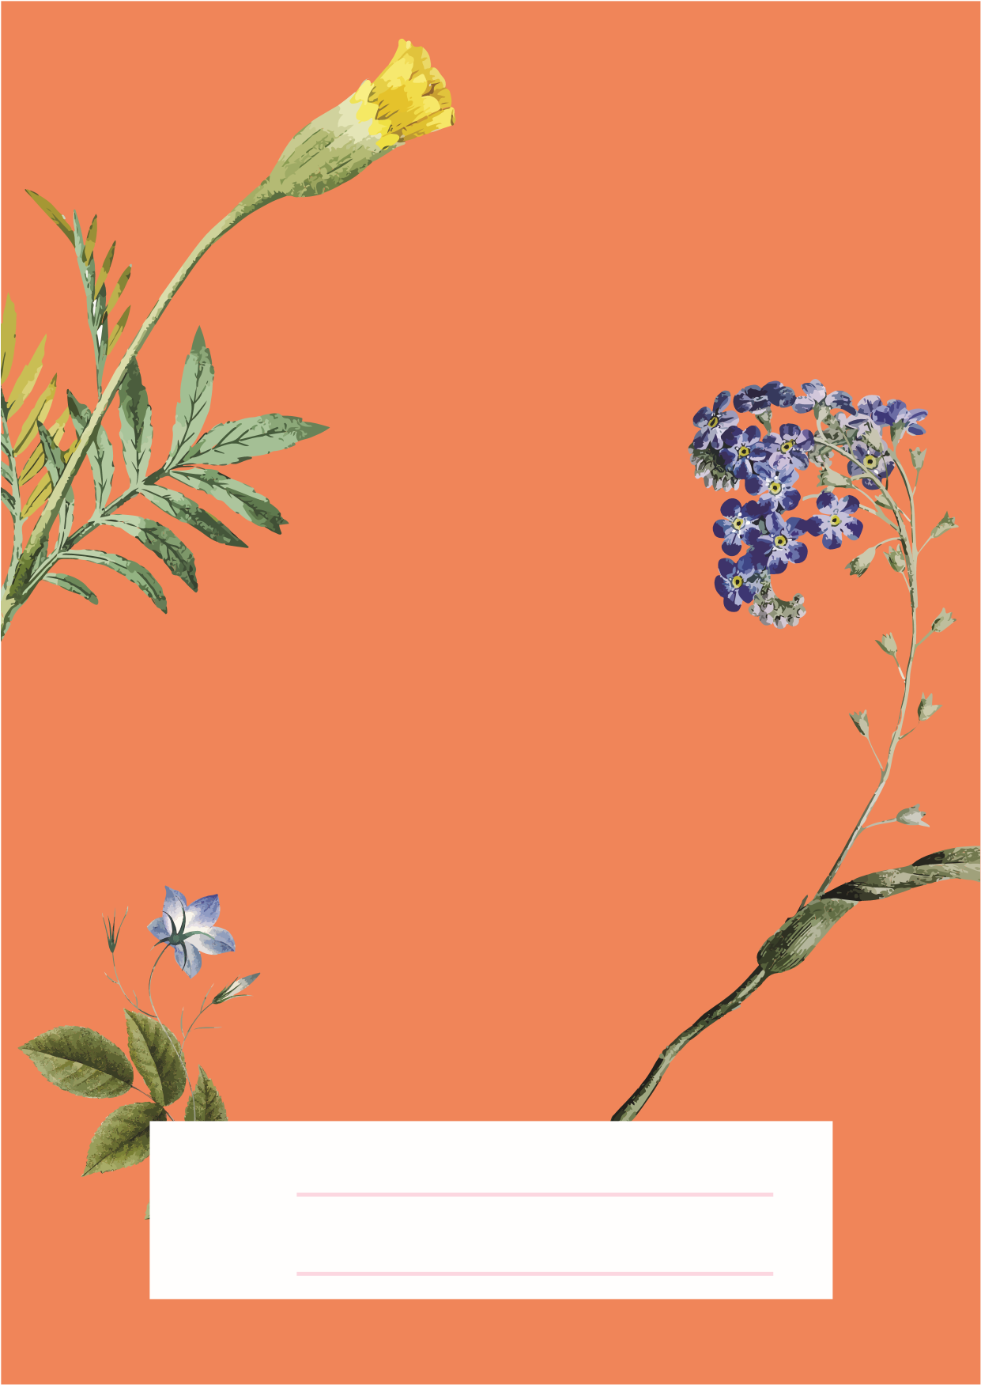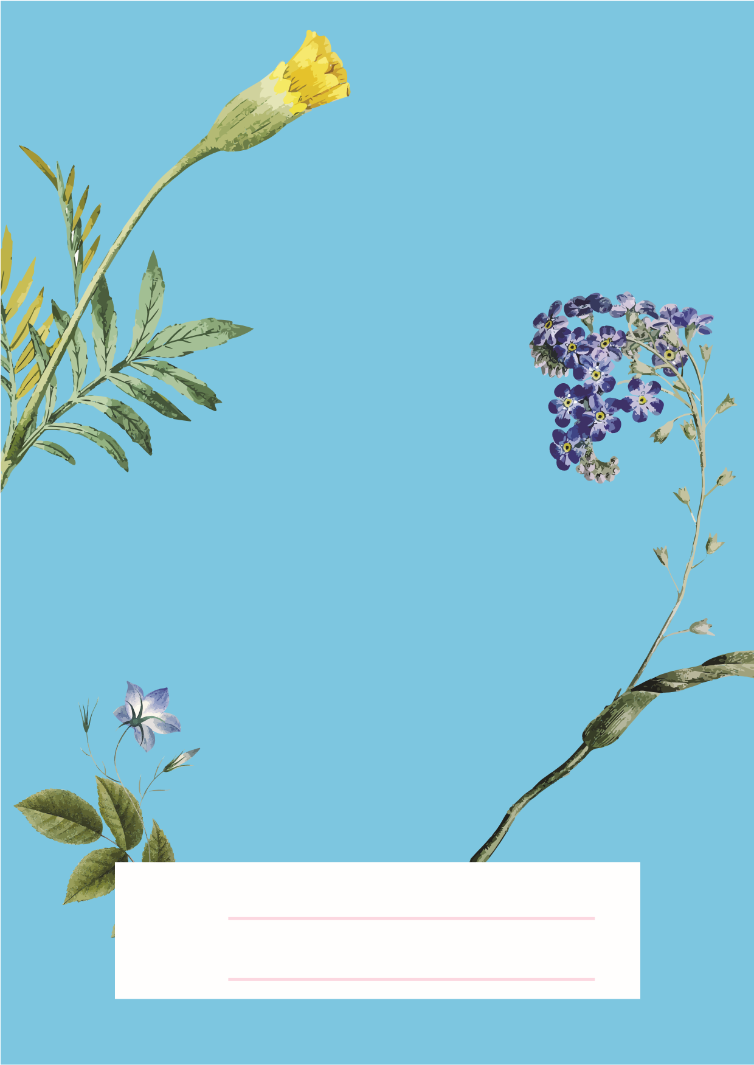
HAPPY
Eid ul Fitr
FROM:
TO:
FROM:
TO:
HAPPY
Eid ul Fitr

